What is the need of OS?

Windows , unix ,Mac ??

Developers,

H/W

OS

S/W

Functions performed by OS

1. File Management
2. Memory Management
3. Processor Management
4. User Management

Windows

Linux > Operating System , ubuntu

Mac OS

Architecture of linux

Hardware

Kernel > Kernel is that part of OS in linux that deals with the hardware

Shell > interactive part

Applications

Utilities

Containers > share kernel with Host OS (that is why they are light weight)

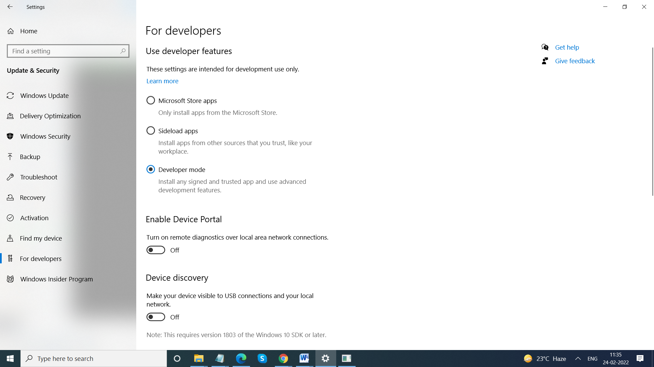

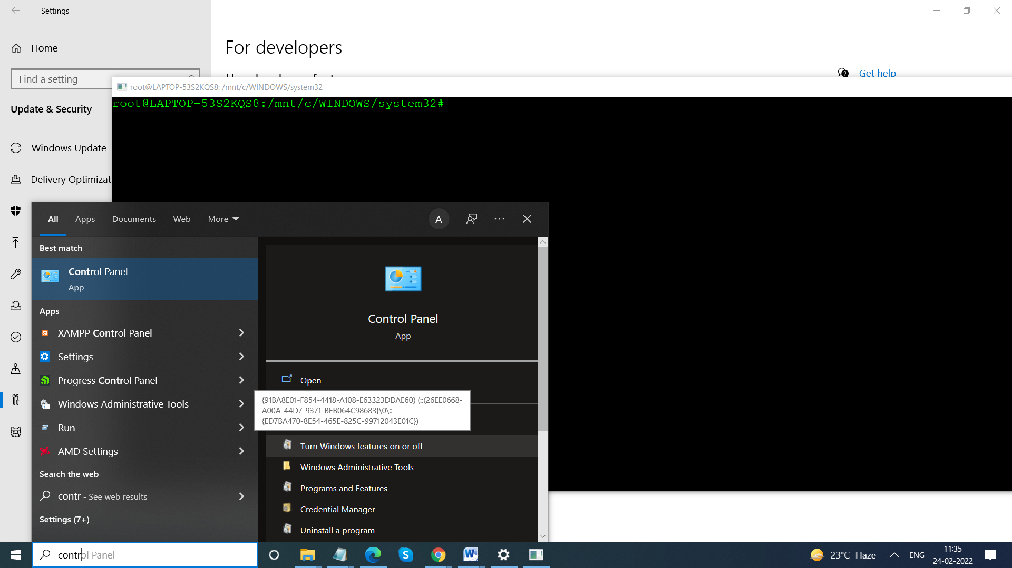

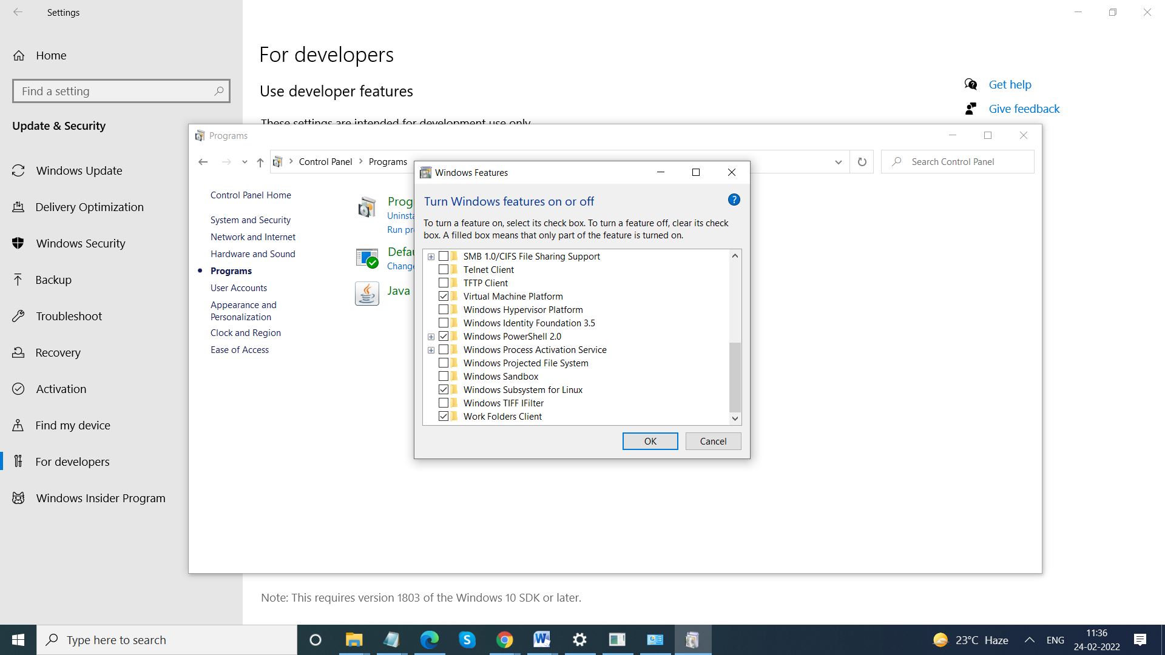

Windows Subsystem for Linux

Open command prompt > Properties , disable > Legacy console option

Bash >